S990 Calibration process
- Download the S990 calibration files that you need from the camera:
In the Ge-i-Cam screen, go to the “ImageSource” register, which is located under the “ImageFormatControl”
Depending on whether you are using Rolling shutter, Global shutter, or Bright Field mode (applied in Global shutter), select the appropriate Offset frame (for example, imgsrc1 for Rolling shutter mode) and Gain frame (imgsrc2 for Rolling shutter mode) and grab a single image.
Display Name | Name
Live Image | Imgsrc0
Offset Table @ Rolling | imgsrc1
Gain Table @ Rolling | imgsrc2
Offset Table @ Global | imgsrc3
Gain Table @ Global | imgsrc4
Offset Table @ Bright Field | imgsrc5
Gain Table @ Bright Field | imgsrc6

Helpful tips:
- It is important to use the “Grab” function and not the “Stream” function.
- Please note that the download will require up to 2 minutes.
- We recommend saving these arrays locally.

- Stream raw images:
In the Ge-i-Cam screen, go to the “ImageSource” register, which is located under the “ImageFormatControl”, and set it back to Live Image (imgsrc0).
Stream images as you would in your application.
- Apply the calibration formula:
To calibrate image, enter the values for each pixel from the streamed image (𝐼𝑚𝑎𝑔𝑒𝑟𝑎𝑤) and the Offset frame (𝑂𝑓𝑓𝑠𝑒𝑡) and the Gains frame (𝐺𝑎𝑖𝑛𝑠) previously downloaded in this formula:
[𝐼𝑚𝑎𝑔𝑒𝑐𝑎𝑙]=([𝐼𝑚𝑎𝑔𝑒𝑟𝑎𝑤]−[𝑂𝑓𝑓𝑠𝑒𝑡])([𝐺𝑎𝑖𝑛𝑠]/16384)
- Repeat steps 2 and 3 for all the streamed images.
The calibration step should occur after the images have been streamed into a computer, with the gains frame, offset frame, and formula kept locally on the computer.

Example:
The streamed image from a sensor with 4 pixels by 3 pixels is represented in the graphic below:
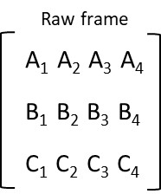
CXP6 processes this sensor data as a 1D array, represented by:
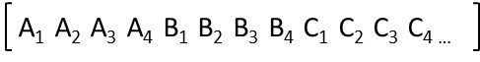
The Gains frame and Offset frame for the same sensor is represented by:
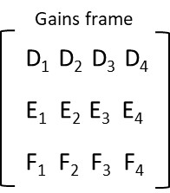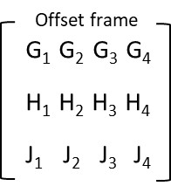
These values are applied to the formula:
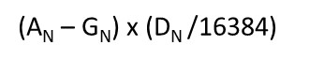
Changing Resolutions:
Resolution is reduced by reducing an equal number of outer columns or rows. To reduce the resolution from 4 x 3 to 2 x 3, one column for each side of the sensor is removed from the resolution:
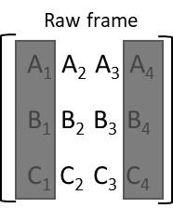
The same columns will need to be removed from the Gains frame and the Offset frame:
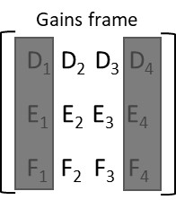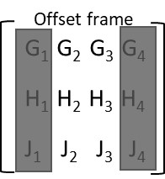

Changing the Offset frames:
The Factory set Offset files are created by capturing a black image at 30 frames per second, at full resolution. If your settings are different, we recommend creating an Offset file specific to your application.
In the Ge-i-Cam screen, go to the “ImageSource” register, which is located under the “ImageFormatControl”. Select the imgsrc0 file, cover the sensor with the lens cap and grab a single black image.
Save it locally.
Use this frame instead of the factory provided offset frame in the equation.

